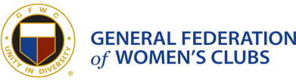

The GFWC Woman’s Club of Westminster, Inc.
Press Release
Contact Mary Lou Poirier
gloupoirier@gmail.com or 410-871-9102

October 20, 2015, Hats for Cancer Patients
The Public Issues Community Service Program of the GFWC Woman’s Club of Westminster, Inc., in partnership with the Carroll Hospital Center, purchased hats for cancer center patients who could not afford them. Fran Rock, Public Issues Co-Chair met with hospital representative, Amanda Vetter of the Carroll Hospital Foundation at the Tevis Wellness Center who received 28 hats donated by the partnership.
This is a continuation of the Woman’s Club’s focus on cancer awareness as an issue on which each of its club community service programs and its committees in partnership with other community service and public organizations have focused over a two-year period.
The GFWC Woman’s Club of Westminster, Inc. is a proud member of the General Federation of Women's Clubs, one of the world's oldest and largest women's volunteer service organizations, dedicated to community improvement by enhancing the lives of others through volunteer service. The Westminster Club partners with local organizations to work towards those same goals. For more information contact Mary Lou Poirier at gloupoirier@gmail.com.
Visit our website at www.gfwcmd.org/clubs/western/westminster_womans.html.

